Performance Dates:

May 23 – June 15

Fridays and Saturdays at 8pm

Sundays at 2:30pm

Rehearsals:

Please be prepared to provide your conflicts at auditions.

* Read through – Saturday, 3/22 at 10am
* Normal rehearsal schedule:
  + Monday through Thursday – 7pm – 10pm
  + Saturday – 10am to 2pm
* Tech and dress rehearsal dates – 5/17 – 5/23

Setting:

Ripcord is mostly set in a double room at Brystol Place Senior Living Facility, though there are a couple of other locations.

Character List:

Abby Binder – a resident, 70s

Marilyn Dunne – a resident, 70s

Scotty – a resident aide, 20s – 30s

Benjamin, Lewis, and other roles – 30s – 40s

Colleen, and other roles – 30s – 40s

Derek, and other roles – 30s – 40s

**Note from the Director**

These audition sides are provided to help you prepare for your audition. You are not expected to memorize the lines. Copies of the sides will be available during auditions, and we will be happy for you to do a cold reading if you do not have the opportunity to review the sides.

|  |  |
| --- | --- |
| Character(s) | Document Page(s) |
| Scotty, Abby | 2 - 4 |
| Scotty, Abby, Marilyn | 5 – 6 |
| Abby, Marilyn | 7 |
| Colleen, Derek, Marilyn, Abby | 8 – 10 |
| Lewis | 11 |
| Benjamin, Abby | 12 - 13 |
| Colleen, Derek, Marily, Abby, Scotty | 14 - 15 |
| Abby, Marilyn | 16 - 19 |

**Characters: Scotty, Abby**

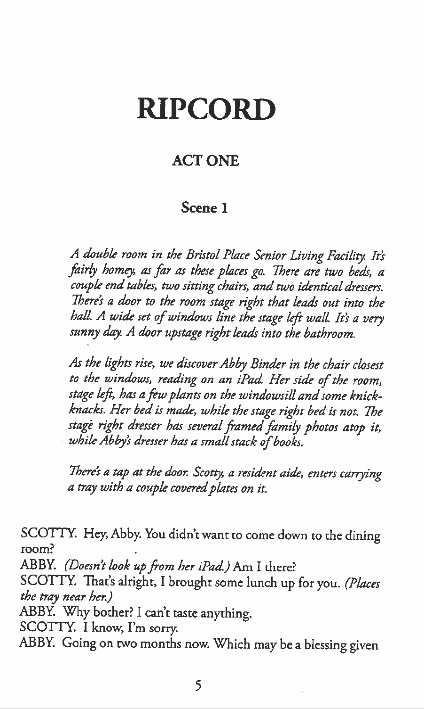

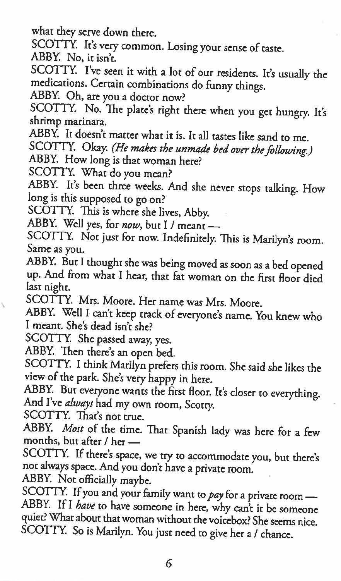

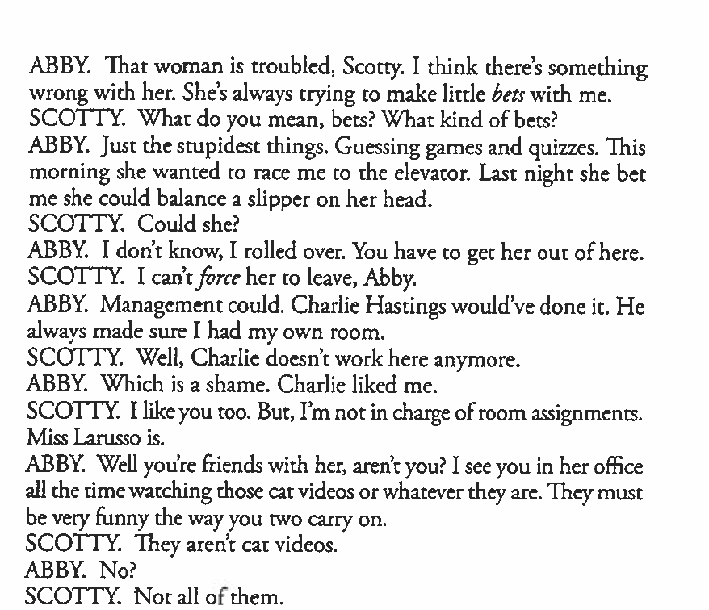

**Characters: Scotty, Abby, Marilyn**

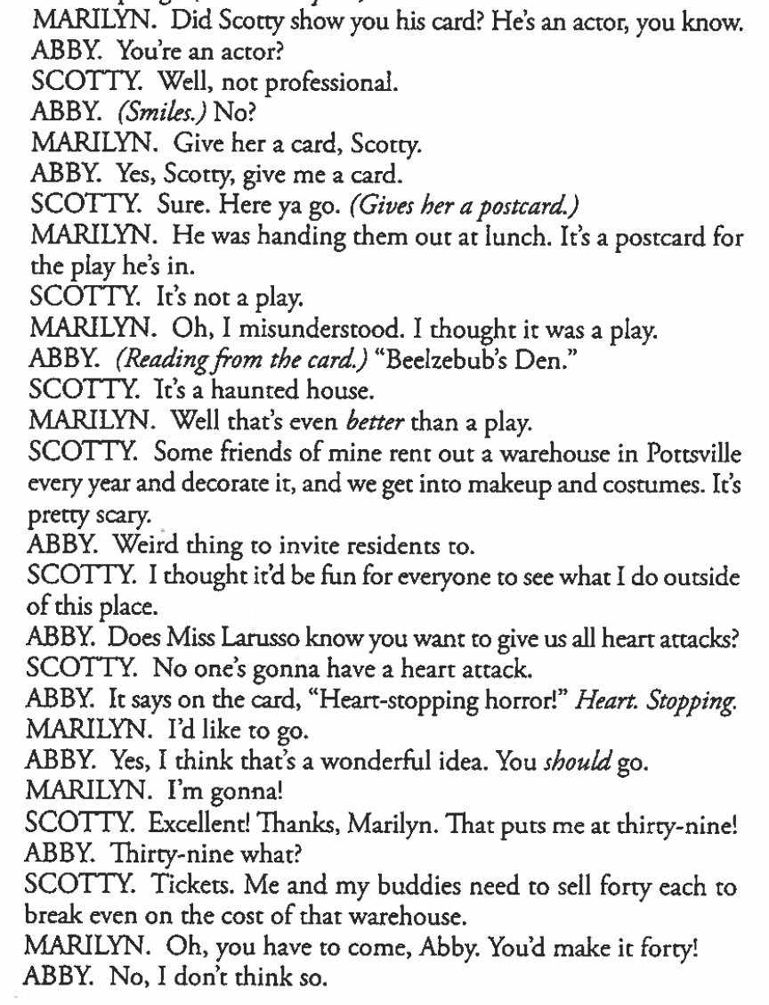

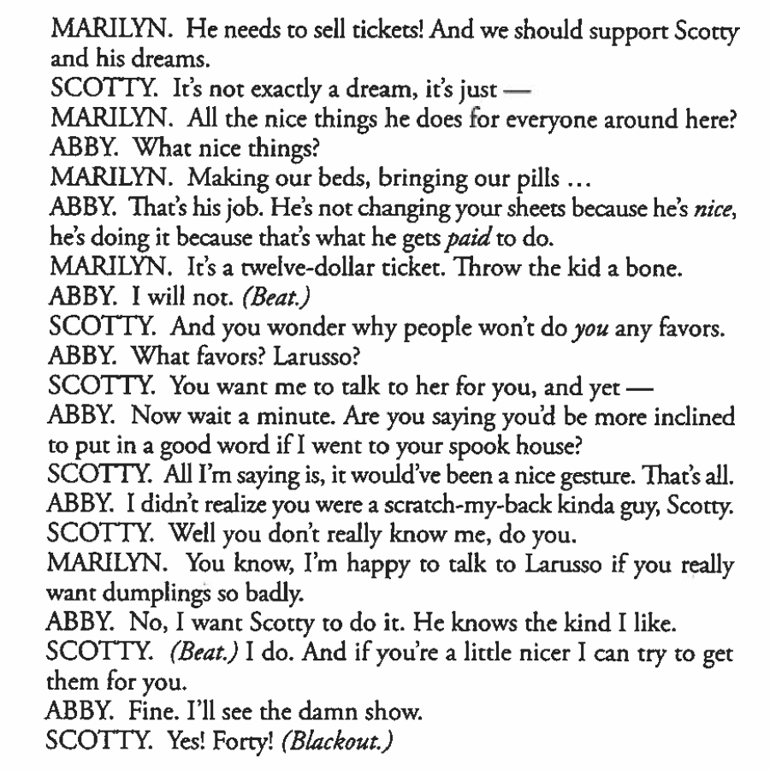

**Characters: Abby, Marilyn**

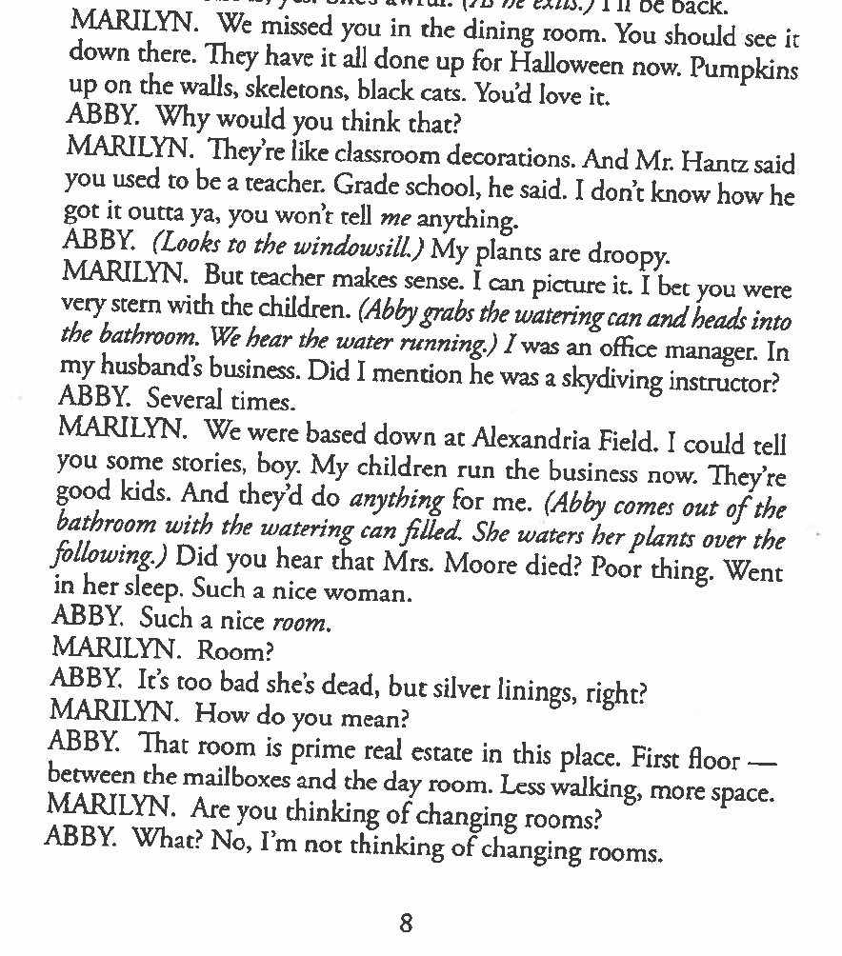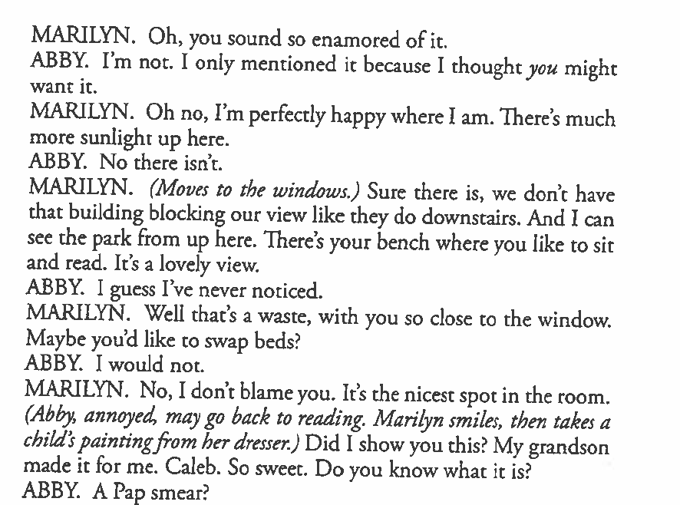

**Characters: Colleen, Derek, Marilyn, Abby**

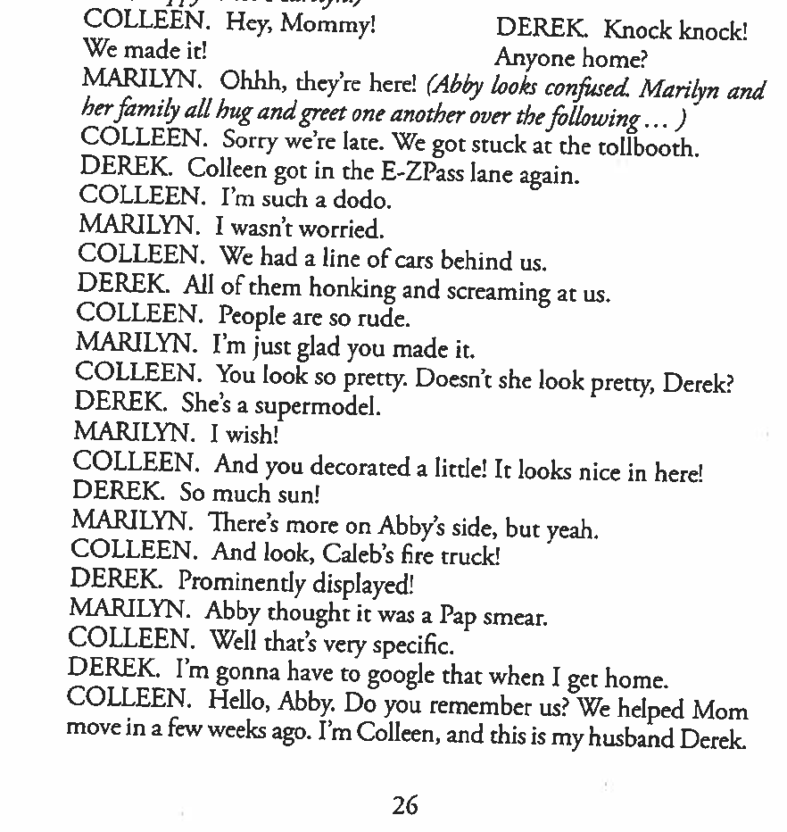

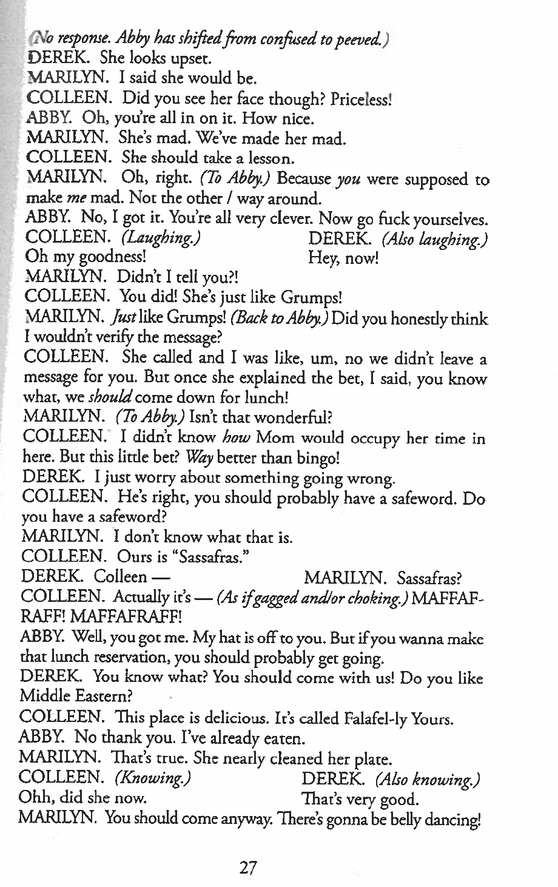

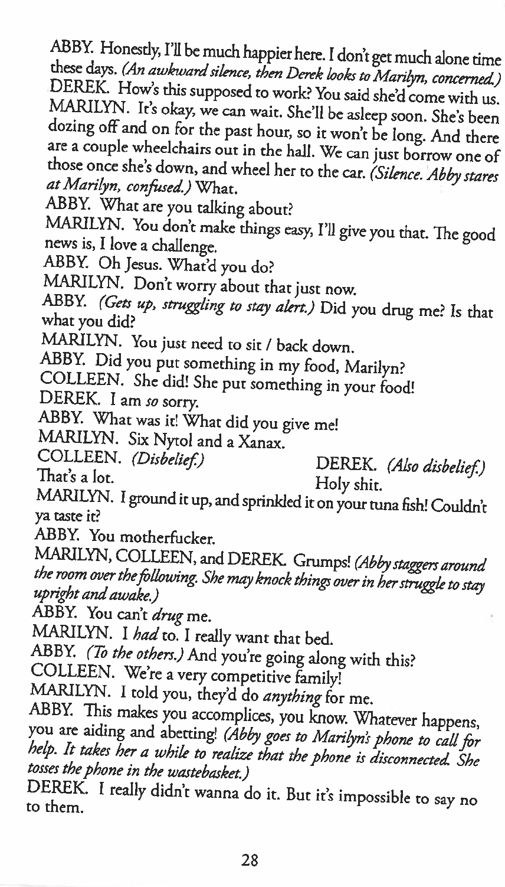

**Character: Lewis**

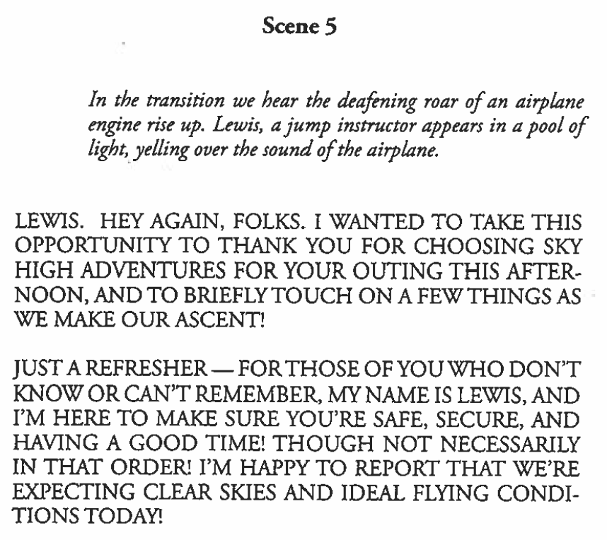

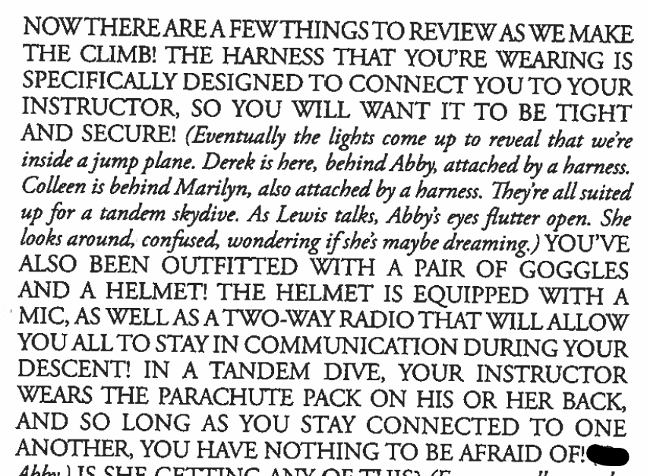

**Characters: Abby, Benjamin**

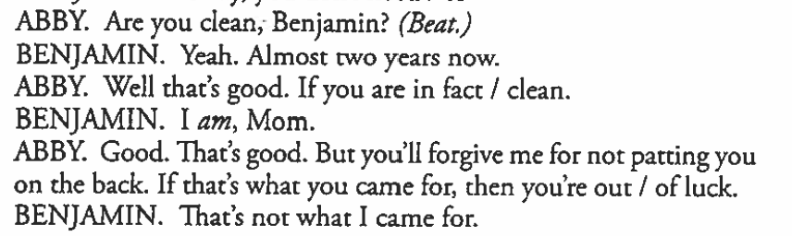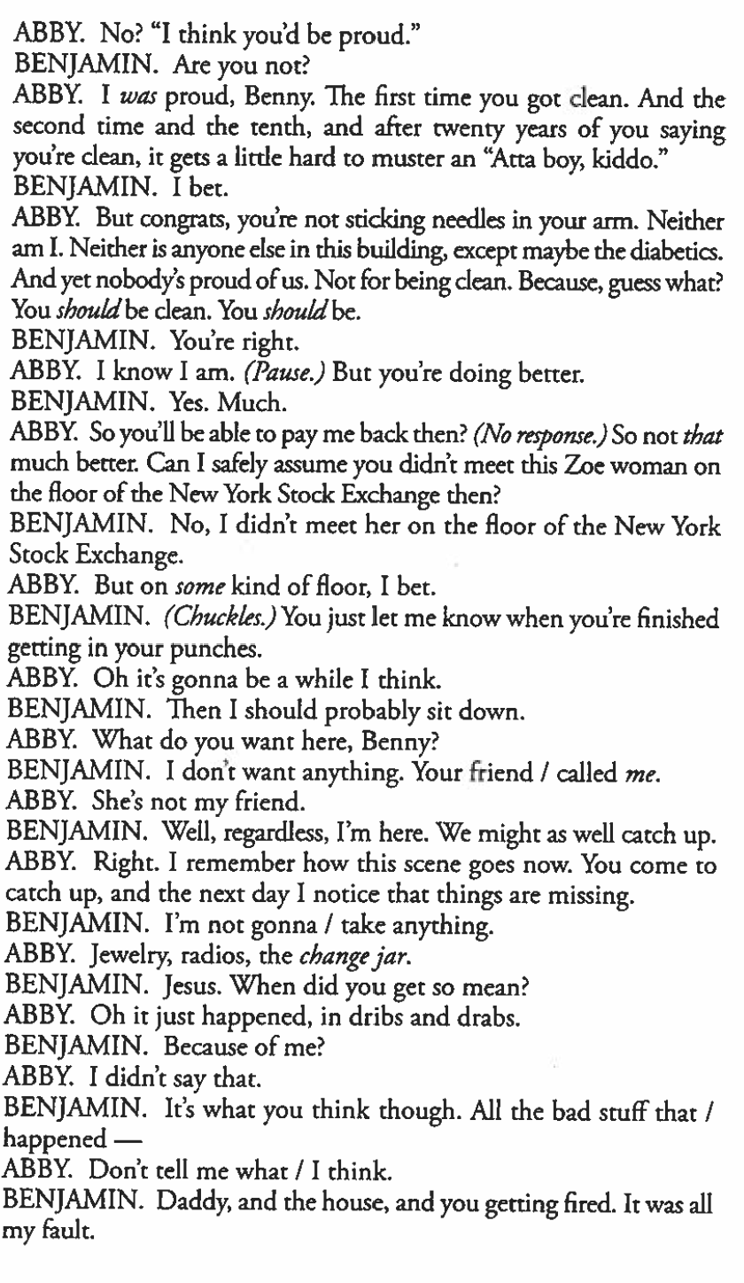

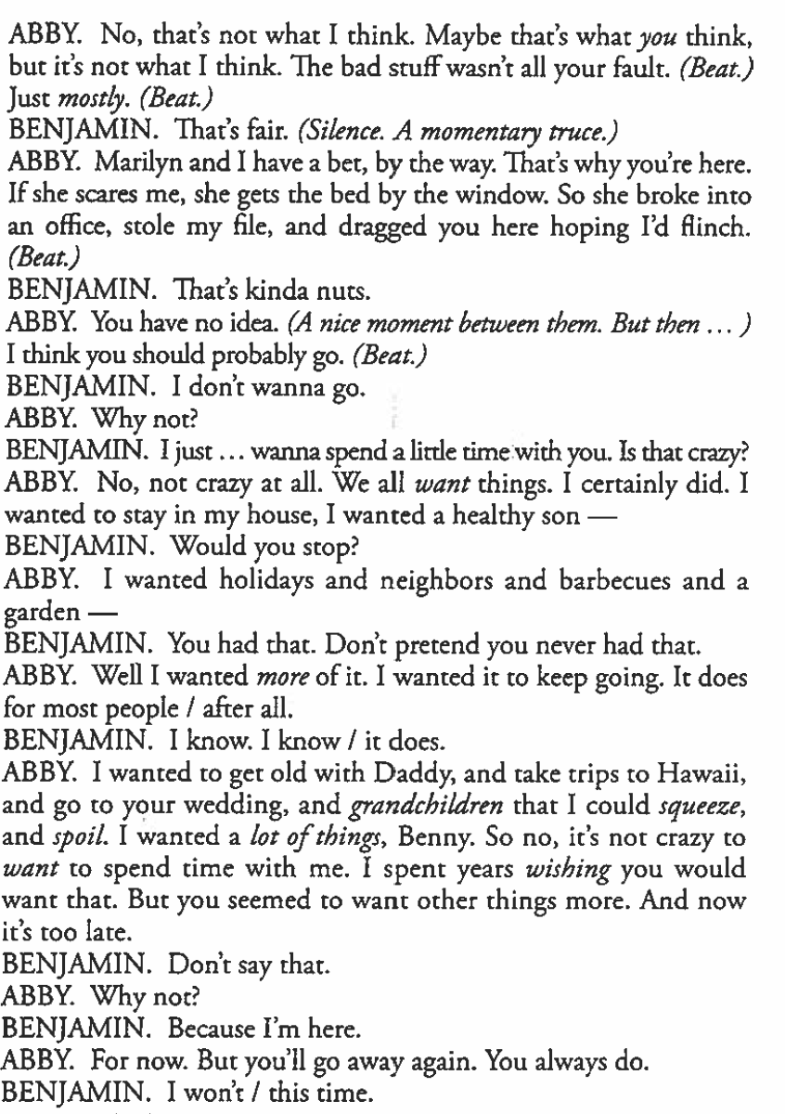

**Characters: Colleen, Derek, Scotty, Marilyn, Abby**

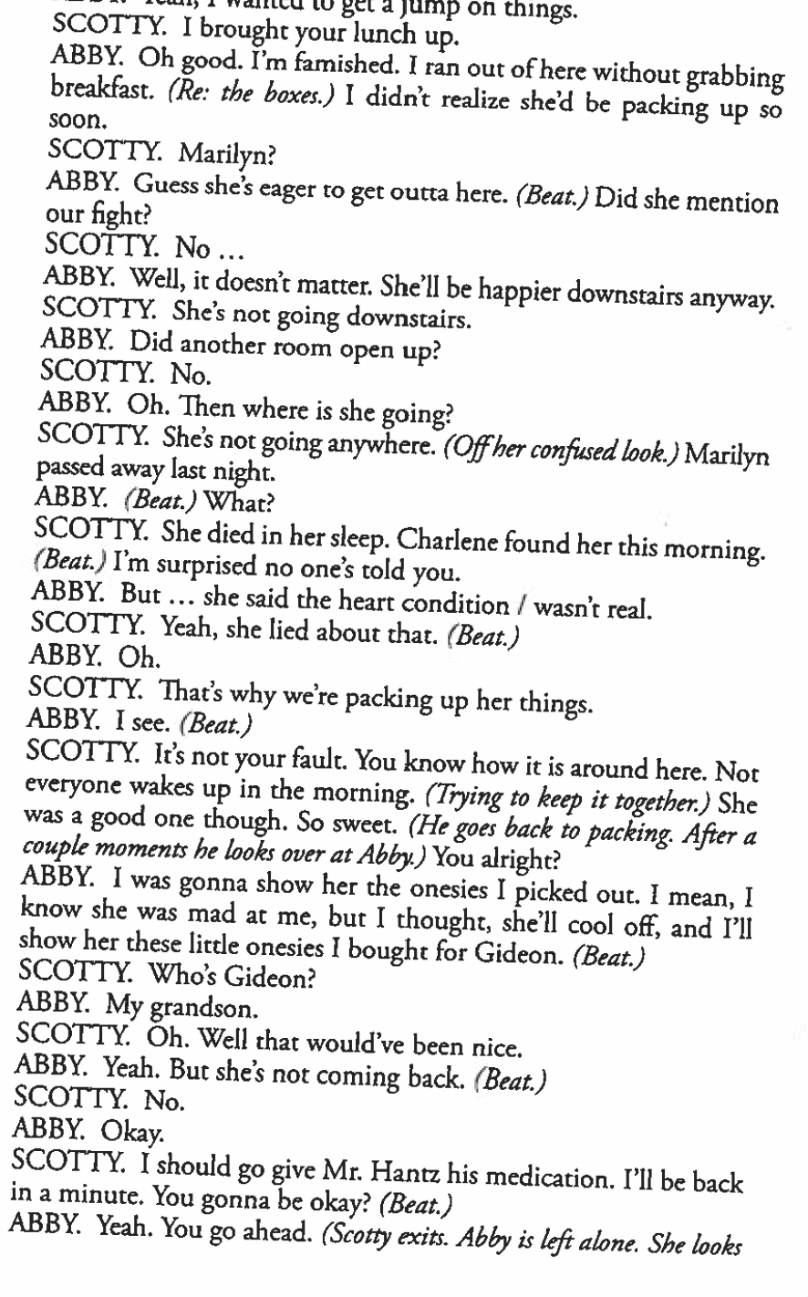

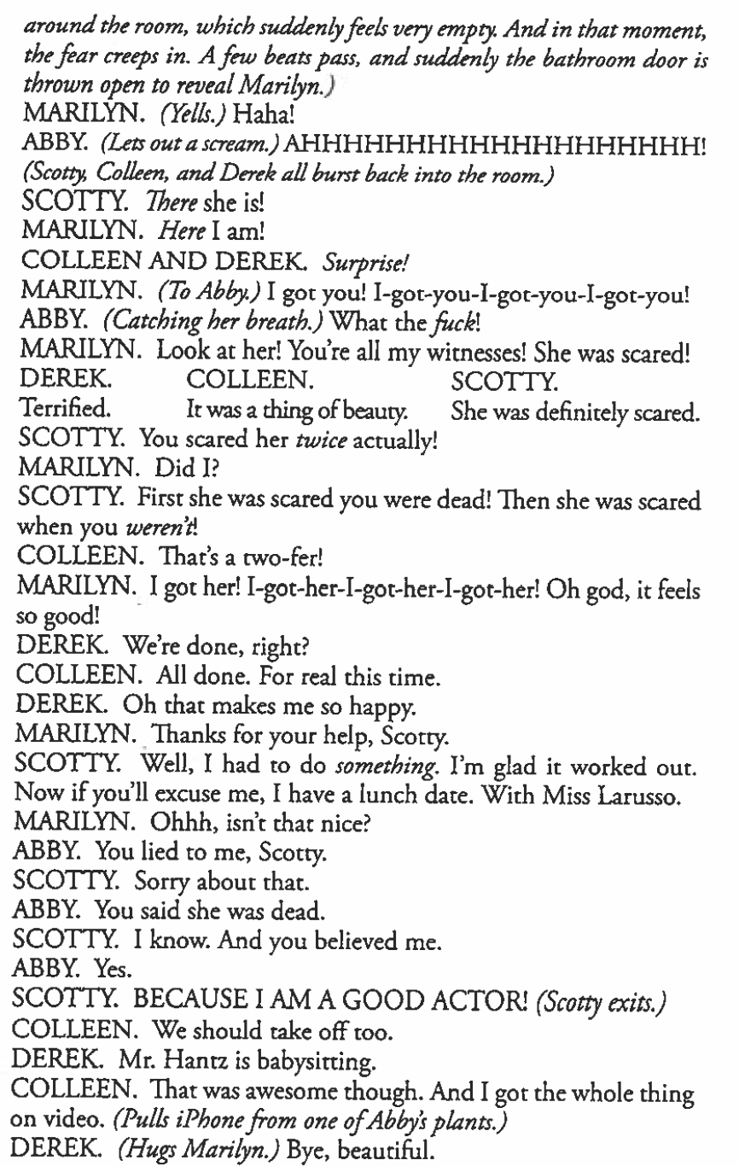

**Characters: Marilyn, Abby**

